Visiting An Mheitheal

# A social narrative for visiting the Art for Action Event

## 1.

We are going to visit Printing House Square and An Mheitheal where you will see many different kinds of art.

When I first arrive at Printing House Square, I may notice that the building looks different from the other buildings on Trinity campus.

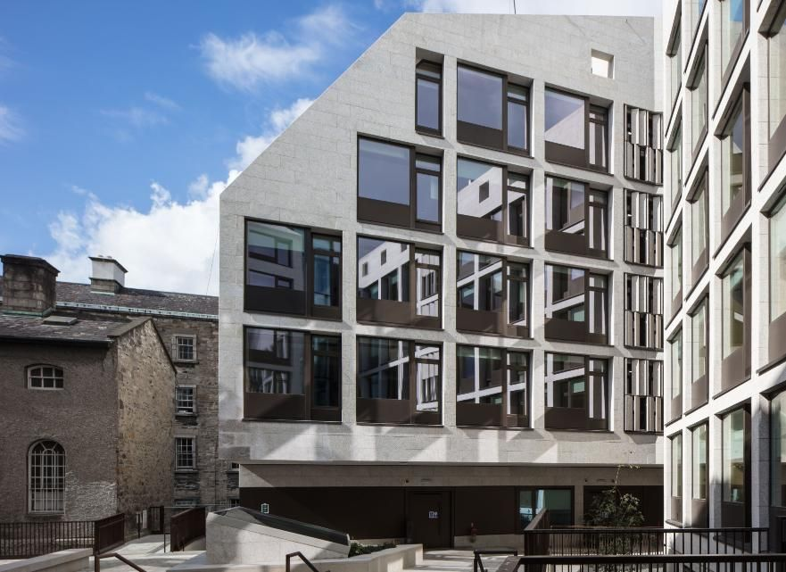

## 2.

I will arrive at the main entrance to the Trinity disAbility Hub in the Printing House Square building. The Trinity disAbility Hub is located here. Sometimes I may need to wait a few seconds until the entrance door opens.

## 3.

I can draw something that I wish I could have, or something that I wish I could be. It feels great to be able to show people what or who I am without even having to use words and just having to use a pencil and paper.